TopCoder Direct Contest VM Instances Management Deployment Guide

Revision History
Author | Revision Number | Date
TCSASSEMBLER | 1.0 | 8/28/2013

Deployment Instructions 3
1. Organization of Submission 3
2. Application Setup 3
3. Ant .Properties File 3
4. Build Scripts Setup 3
5. Database Setup 3
6. Deployment Instructions 3
6.1. Deploy direct application 3
7. Before the testing 4
8. Verification 4

Deployment Instructions

Organization of Submission
docs
Contains DeploymentGuide.doc - this file
direct
Contains all changed file for direct trunk in this assembly, the change is based on revision 232921
test_files
Contains the init.sql file for VM related table setup for testing.

Application Setup
The direct application is expected to be deployed to the following environment:

JDK 1.5
JBoss 4.2.3.GA
Informix DS 11.0

Ant .Properties File

No update for this contest, just follow the existing one in VM.

Build Scripts Setup
The ant command following will be used to deploy direct application.
1. deploy to deploy the application to jboss server.
2. deploy-apache-static to deploy all the static files to apache server.

Database Setup
- Login to VM as “direct” user.
- switch to “informix” user:
su - informix
Use “1nf0rm1x” (quotes for clarity) password.
- Upload "init.sql" file from “test_files” folder of submission to the /tmp/ folder on VM.
- Execute update SQL:
cat /tmp/init.sql | dbaccess
- Switch back to “direct” user:
exit

Deployment Instructions

Deploy direct application
Following steps will help you deploy the direct application.
- Login vm as ‘direct’ user
- Upload my submission to ~/temp_files, assuming the file name is submission.zip.
- jbb
- ./kill.sh (when "kill -9 jboss and backup logs?" asked, enter 'y')
- cd ~/direct
- svn up –r 232921
- cd cloud_vm_service
- svn up -r 232915
- cd ~/temp_files
- unzip submission.zip
- cp -r submission/direct/* ~/direct/
- cd ~/direct
- ant -f cloud_vm_service/build.xml dist_tcs
- ant deploy
- ant deploy-apache-static
- jbb
- ./start.sh
- use 'tn' command to see the jboss is properly started.

Before the testing

Please add your vm ip to your hosts file. And point it to cockpit.cloud.topcoder.com

Verification
Notes, the screenshots may not match with last submission, as some are taken earlier. but they are properly implemented in final version.

  - Visit Home Page https://cockpit.cloud.topcoder.com/direct/,
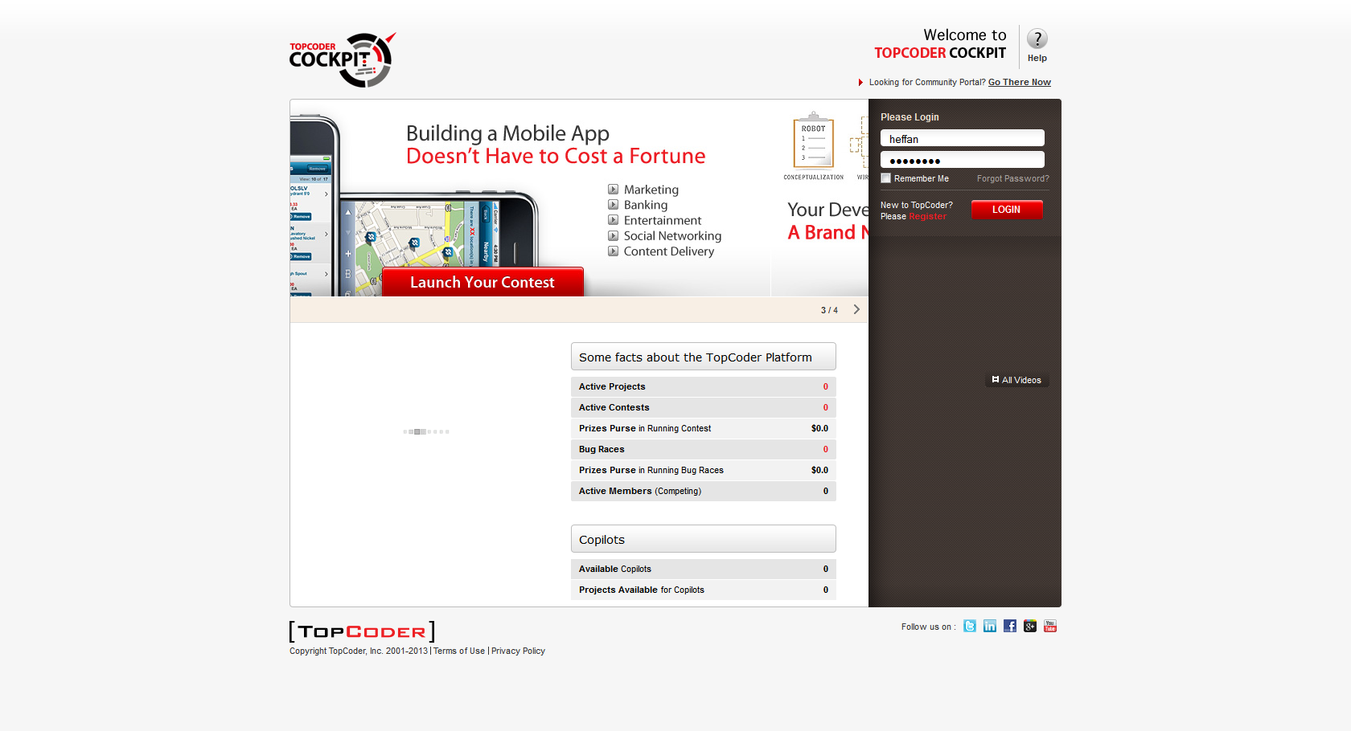

  - Login with heffan/password, the page will be redirect to Enterprise Dashboards,
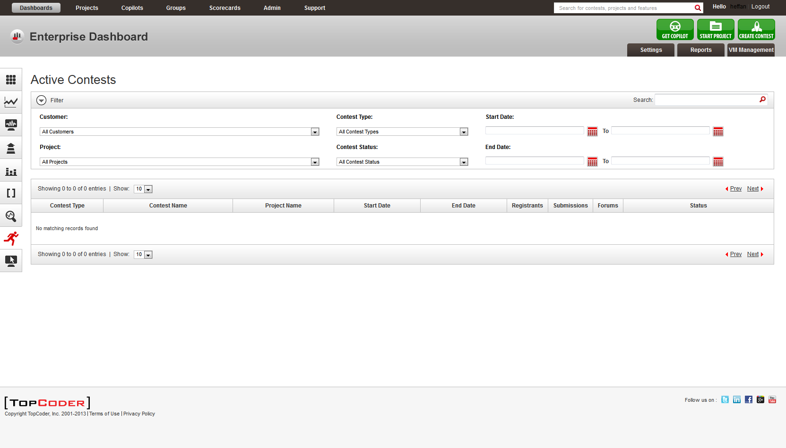

  - Click the CREATE CONTEST button on the top right to create a contest.
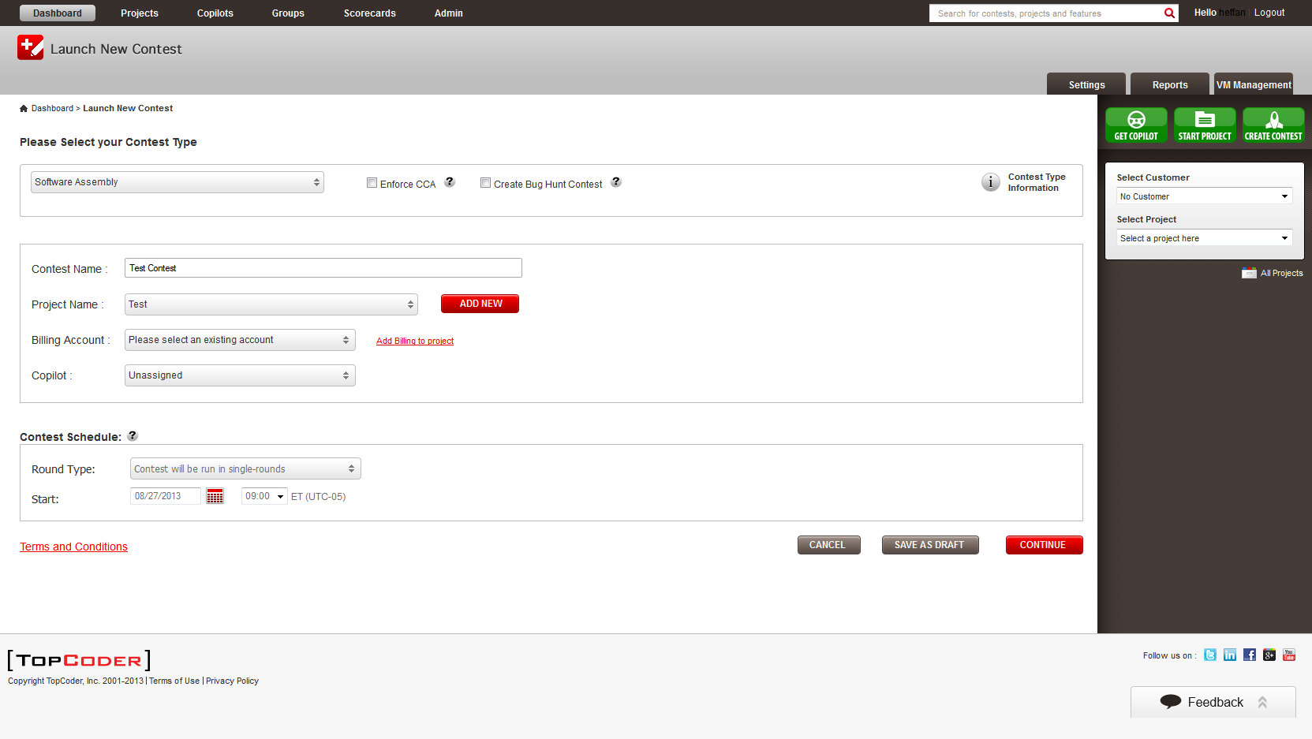

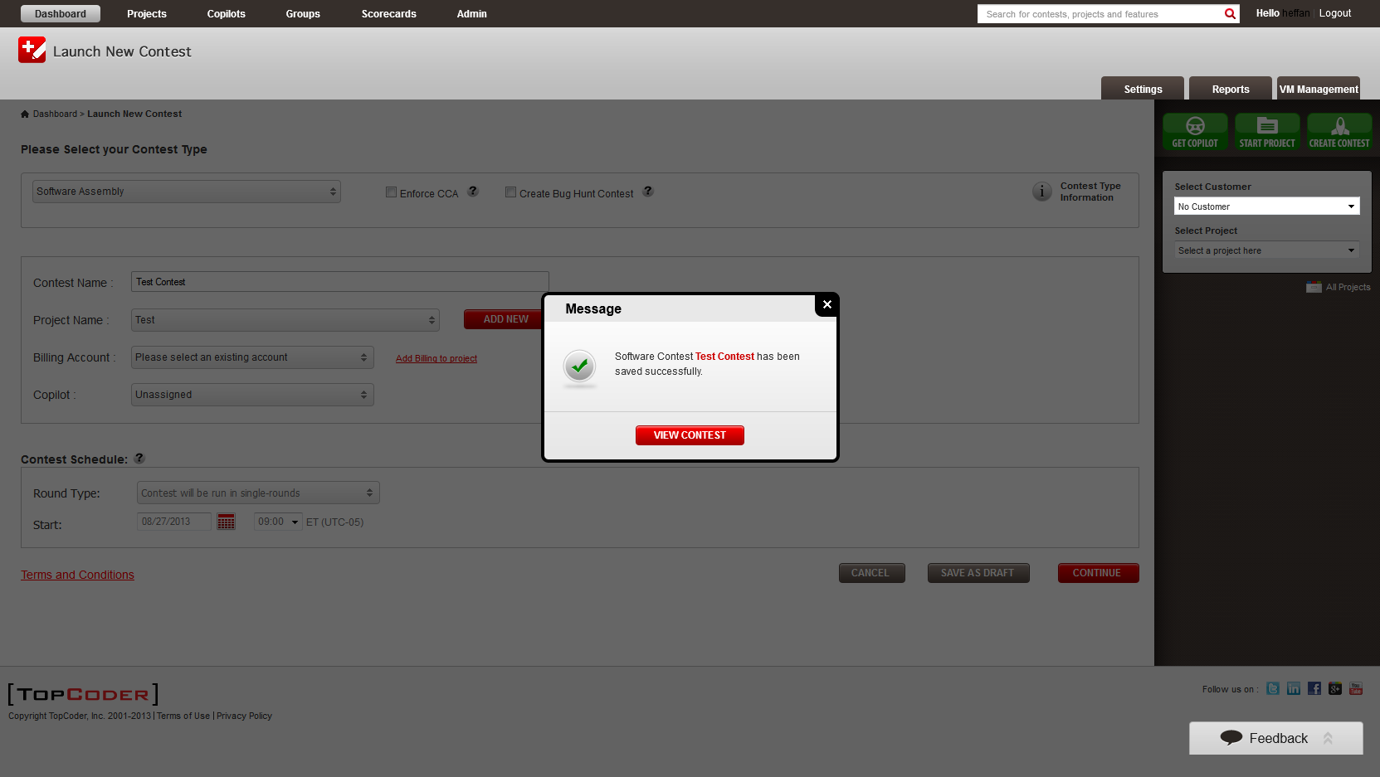

  - Click the VIEW CONTEST button to go to the contest detail page.
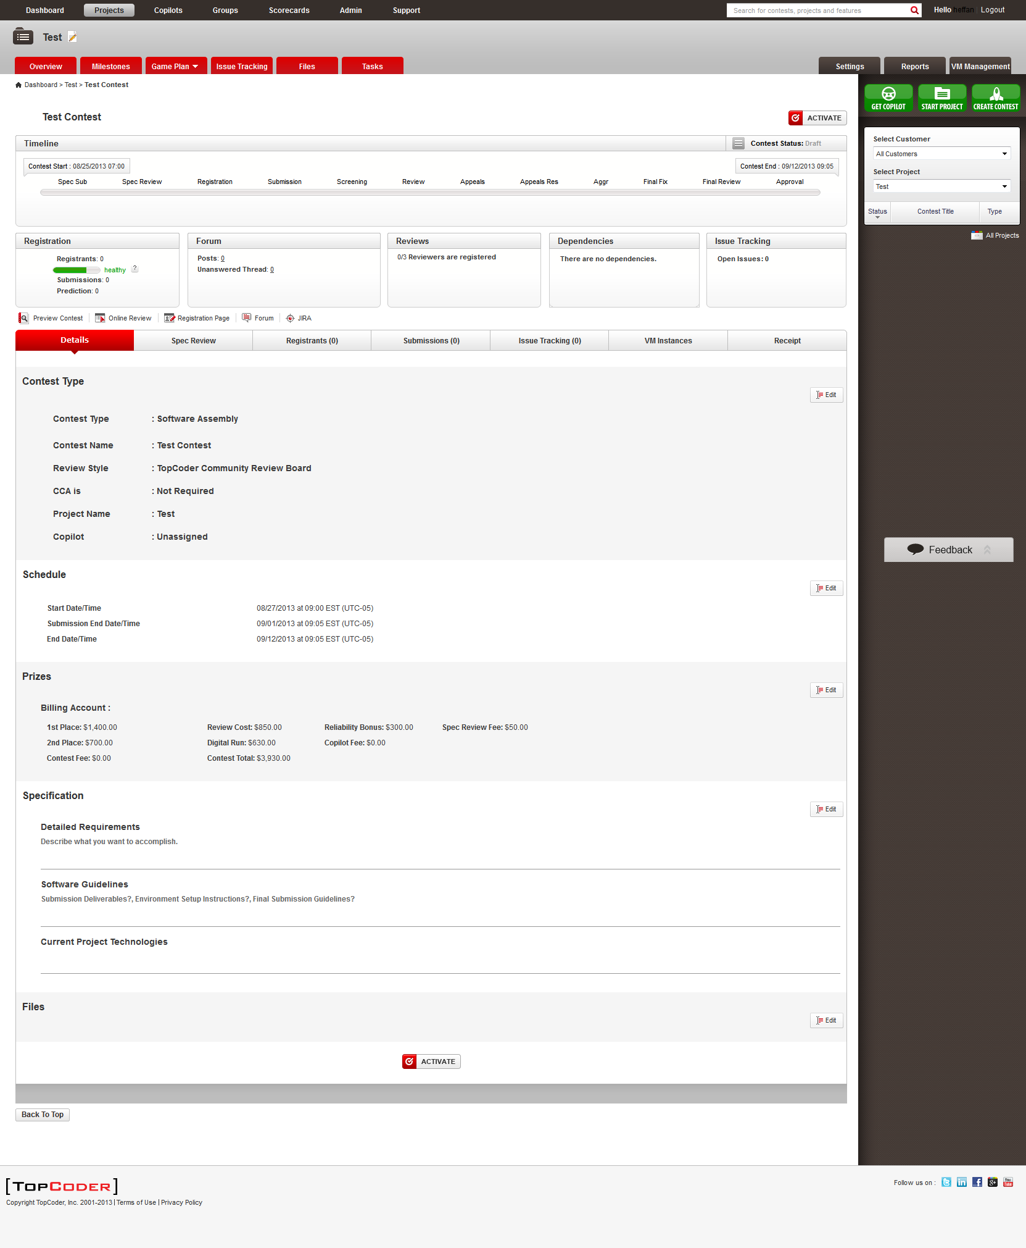

You can see a VM Instances tab is available.

  - Click the VM Instances tab (note, the page is slightly different for final version, as it is taken earlier, I don't want to clean the database, as there are a lot of data created).
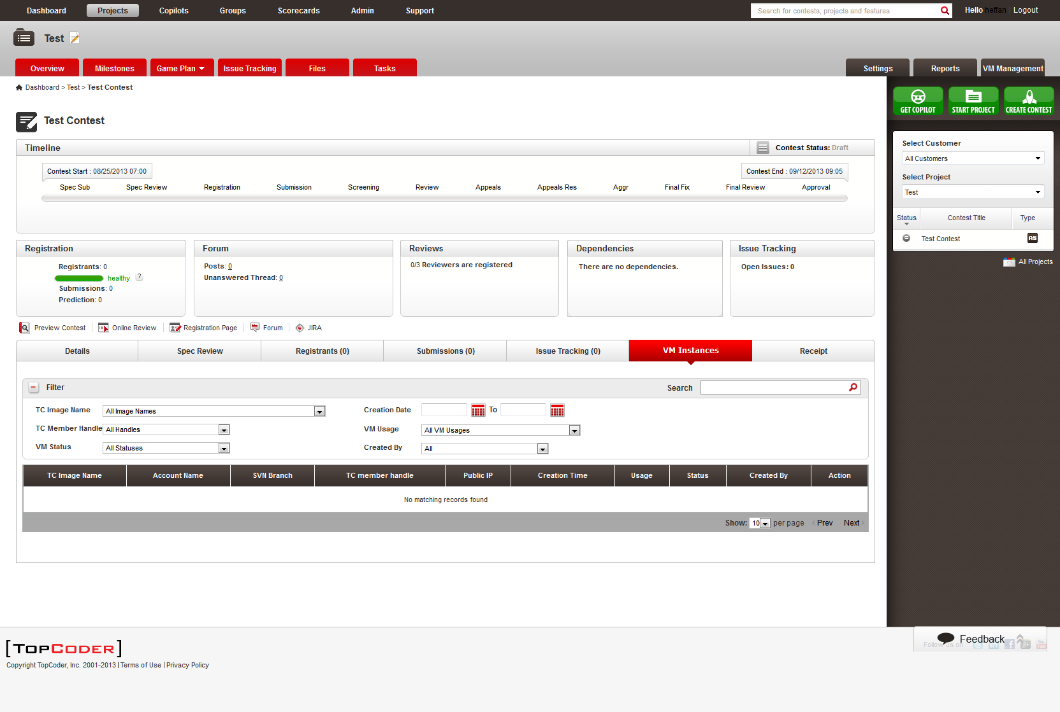
  - Click the VM Management Tab, you can see
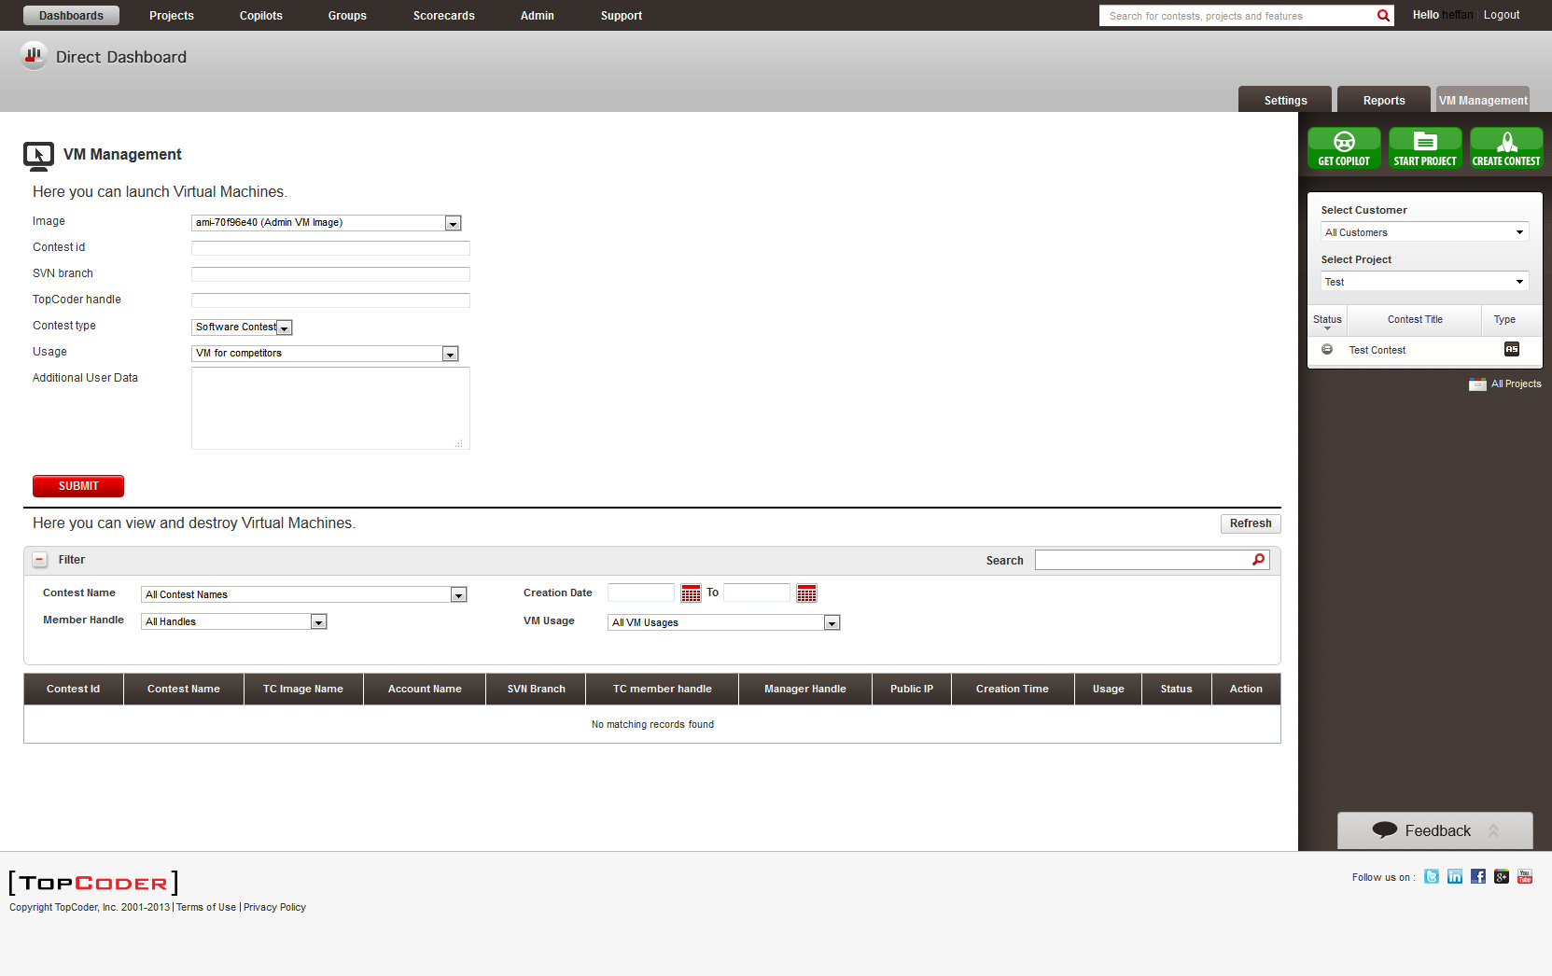
  - Before creating VMs for different users, we should add permissions for users. Click the Settings tab and then select Permission Panel, and add permissions like following
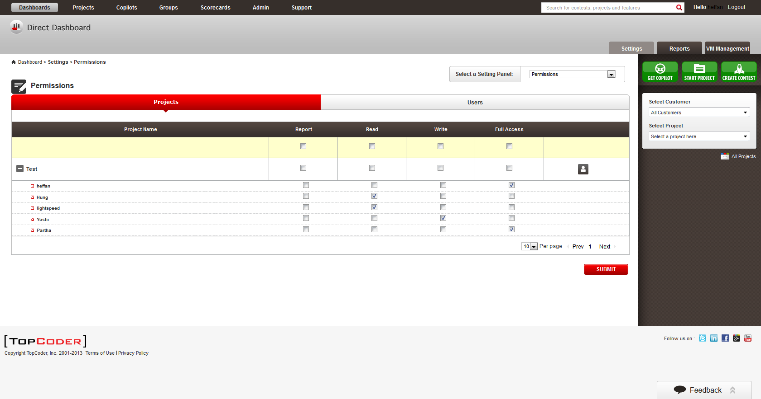
  - Now switch back to VM Management tab.
You can add various VMs for testing purpose, based on init.sql, you can add VMs for user, twight and sandking.

Please try with different combination, like different contest type, different branch name, different usage options.

then terminate some VMs created.

Notes, heffan has Administrator Role, Hung has VM Manager role. they can be used for creating VMs.

  - Return back to VM Instances Tab for contest, you can see by default, it will only display RUNNING VMs.
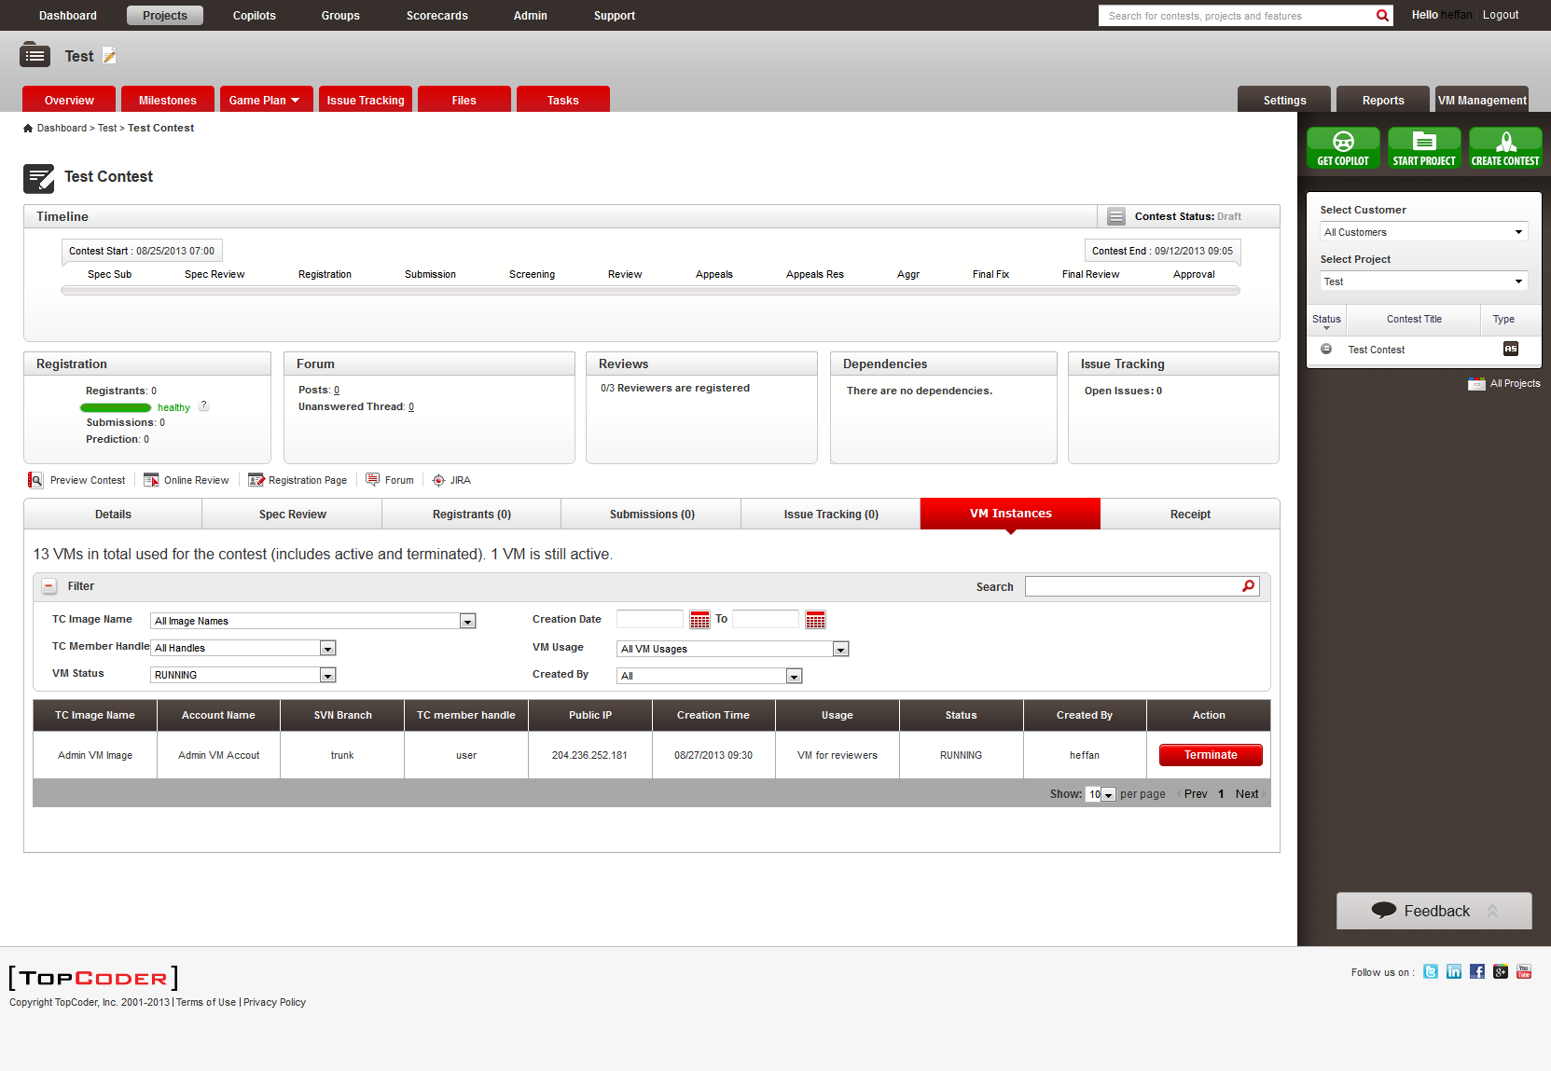
  - Change the VM Status to ALL Statuses option, you can see all VMs.
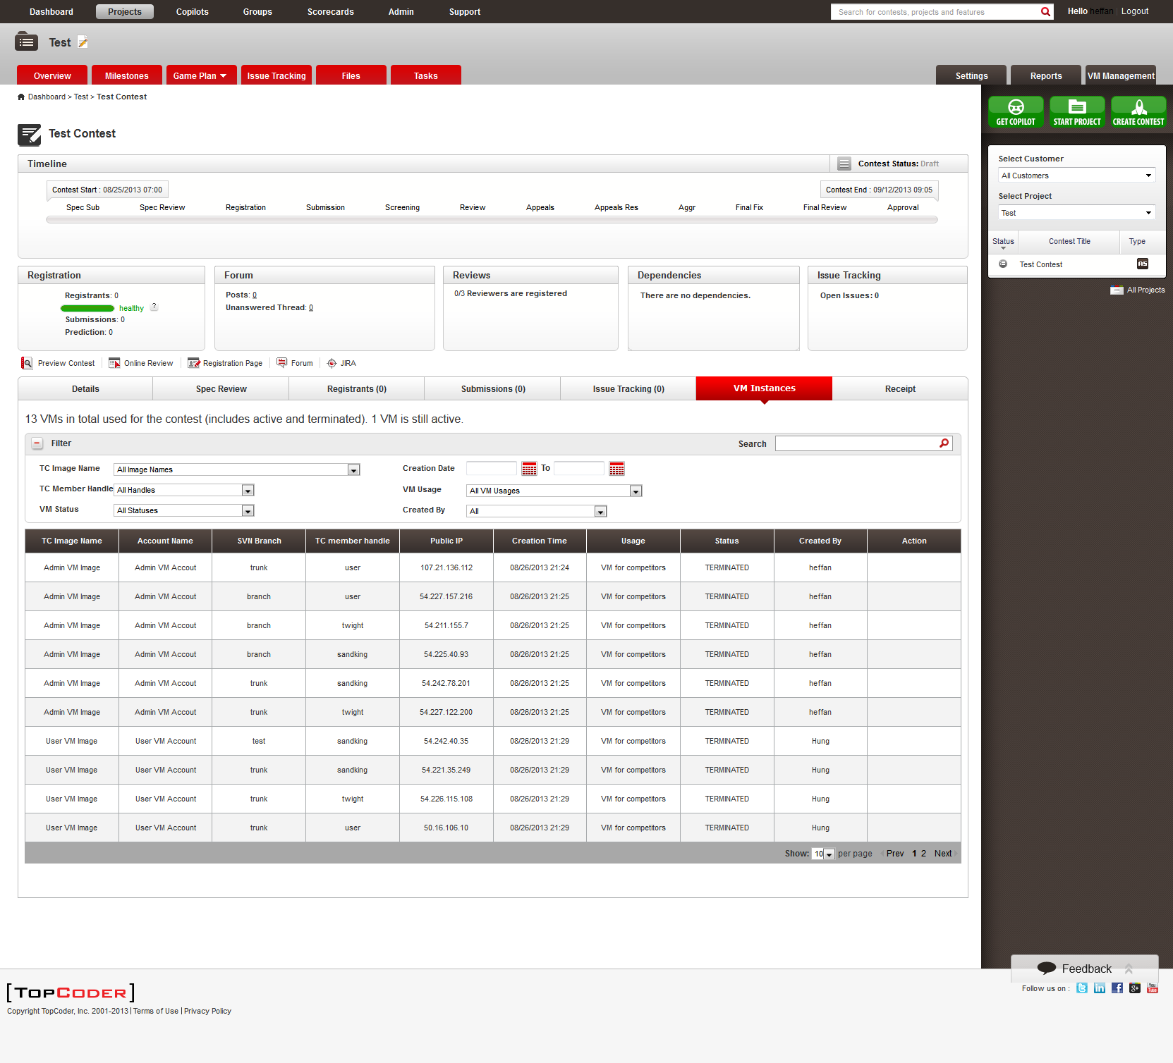

Pagination is supported too.

  - Change TC Image Name Dropdown option, you can see
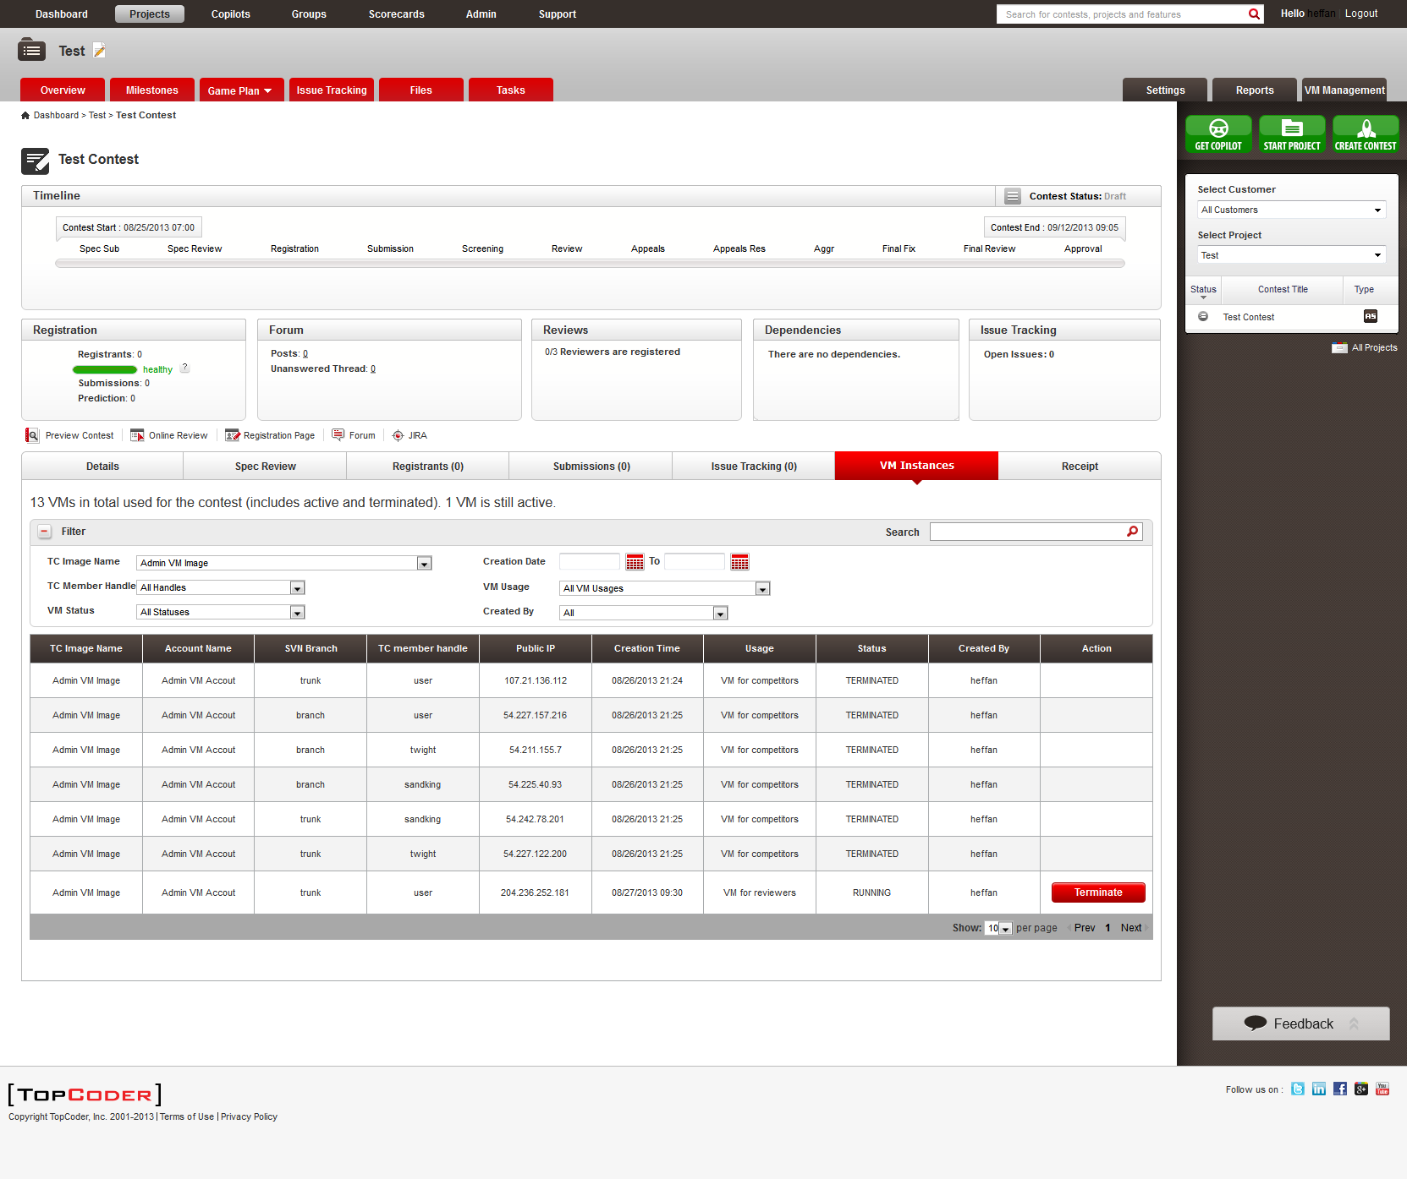

the same to other filter options.
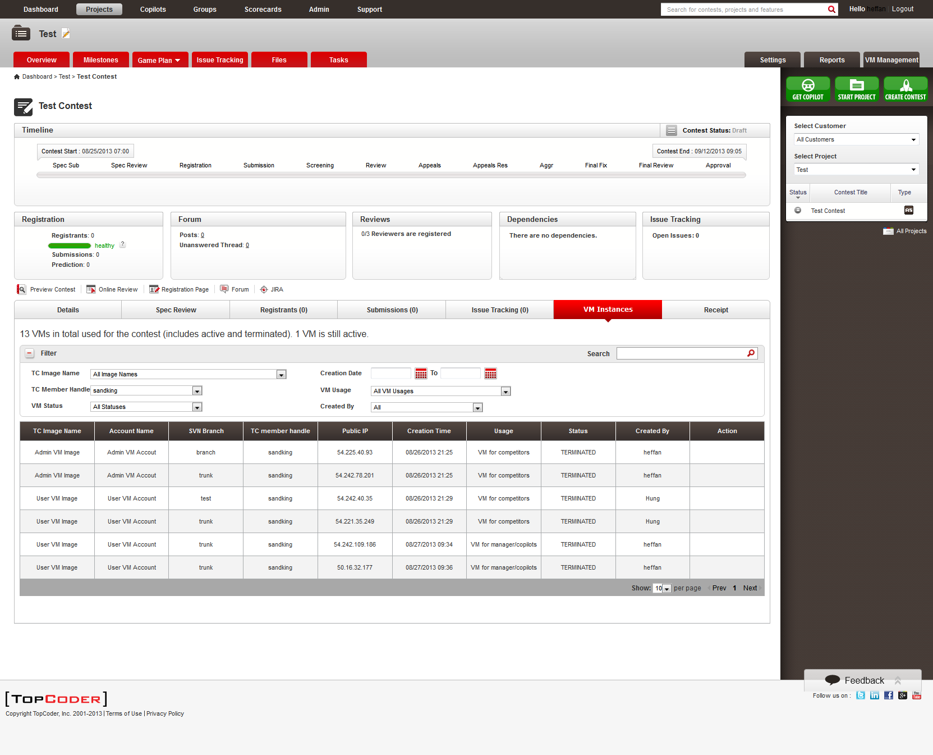
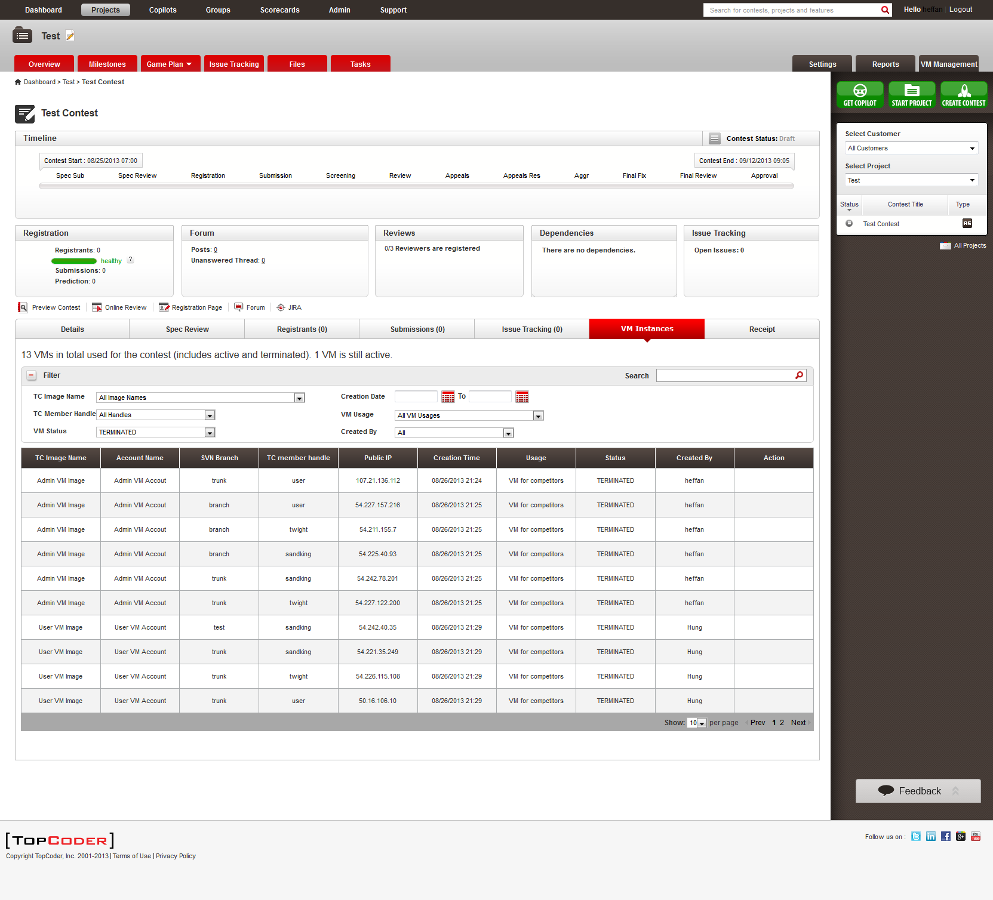
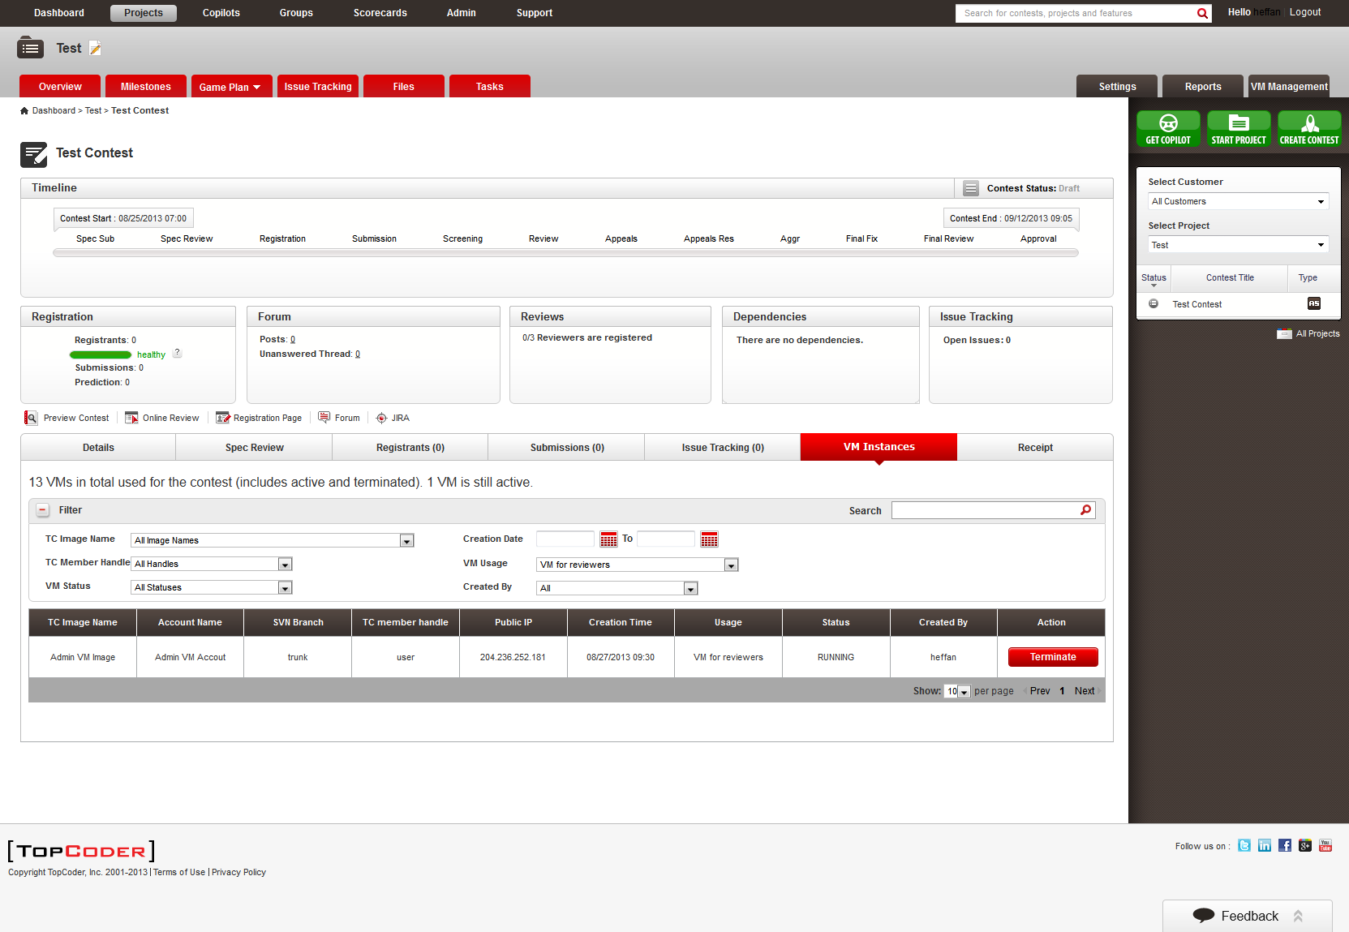

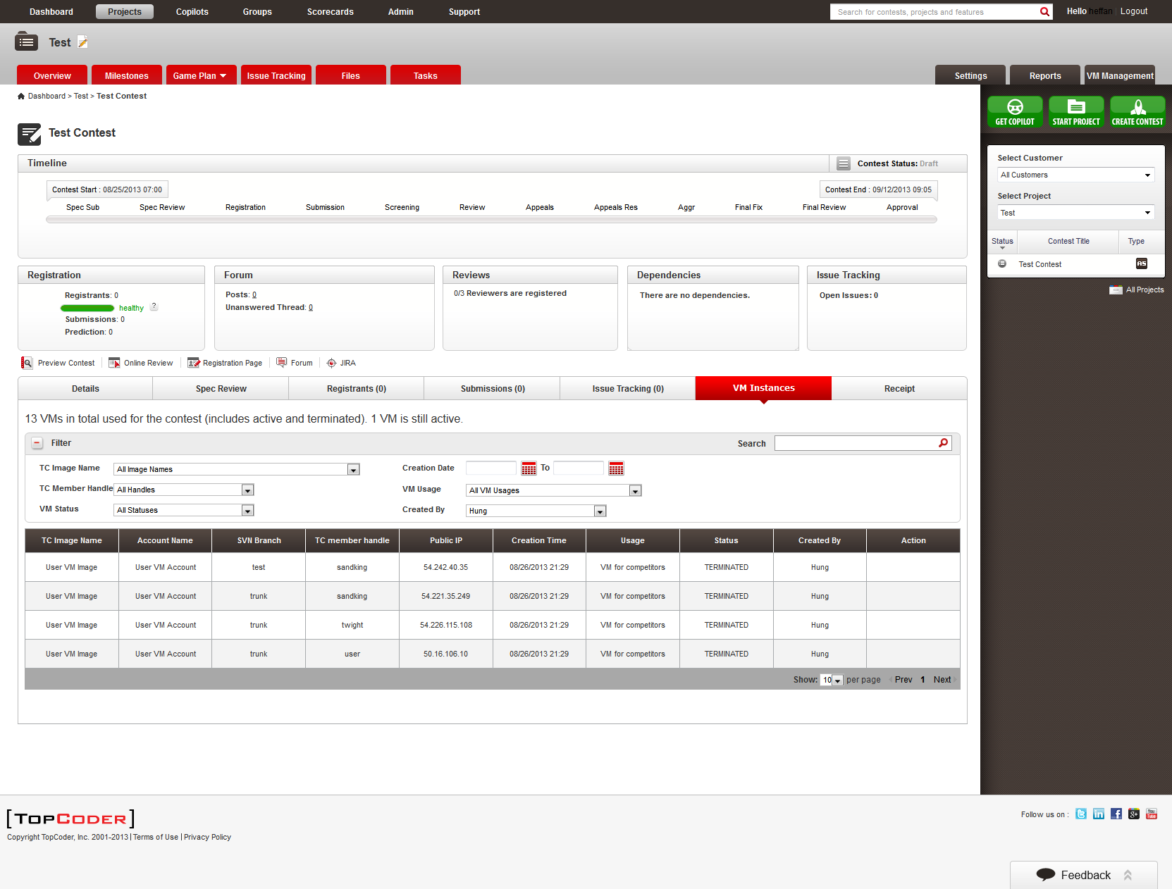
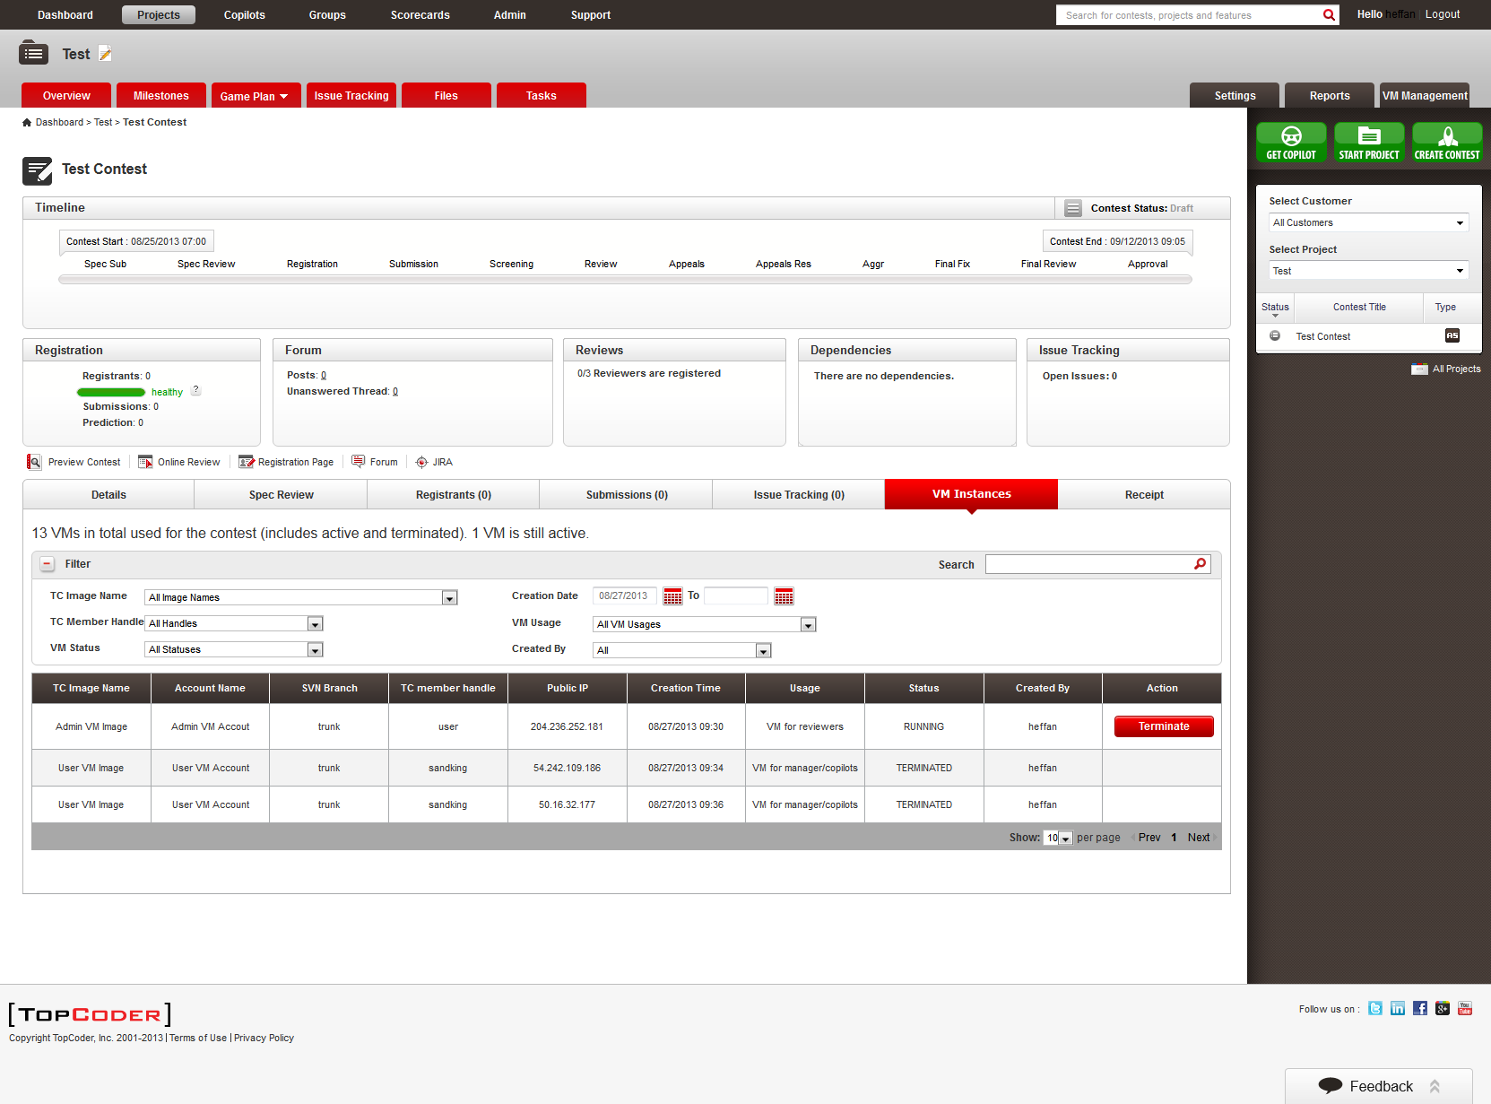

  - Clear the Filter options, and input 'branch' in search box, you can see the table data is properly filtered.
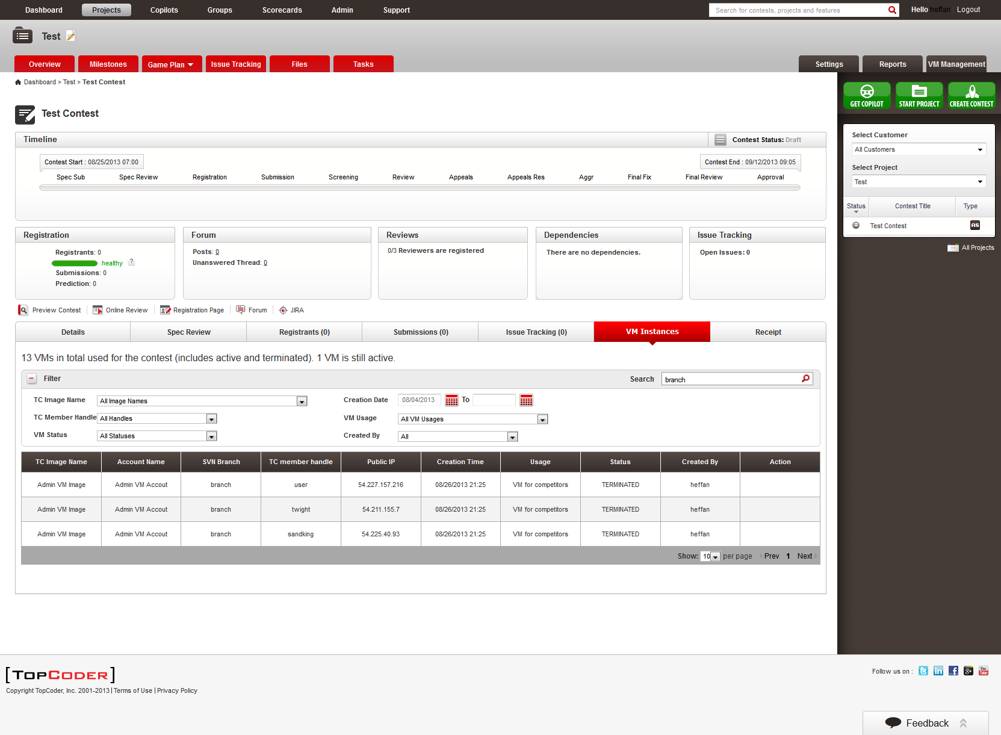
  - Now, try to login with different users with different permissions
Hung - read permission
lightspeed - read permission
Yoshi - write permission
Partha - full permission
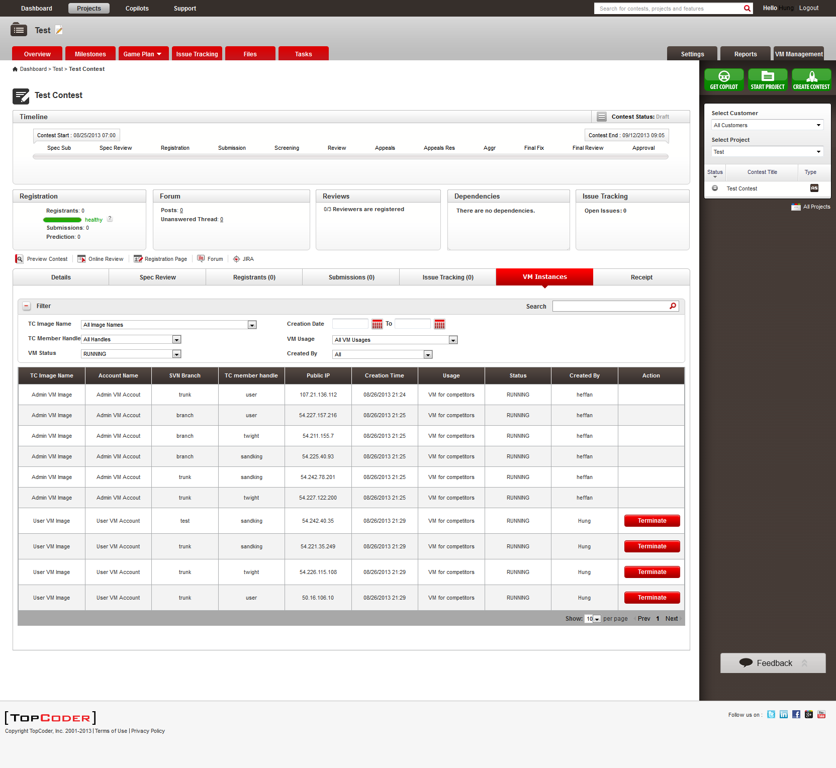
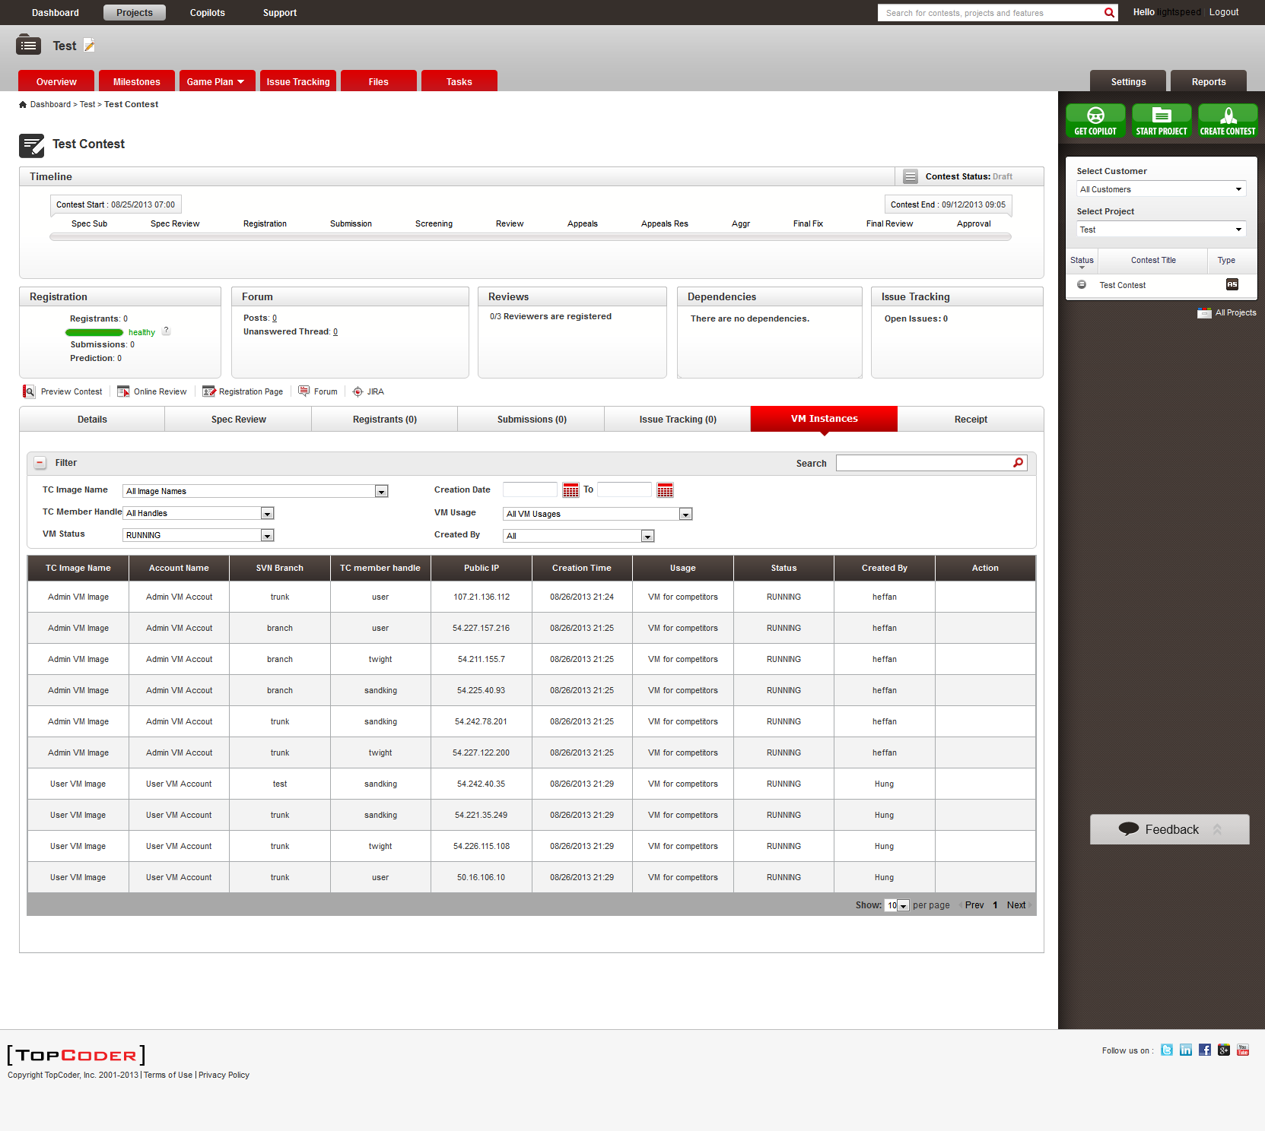

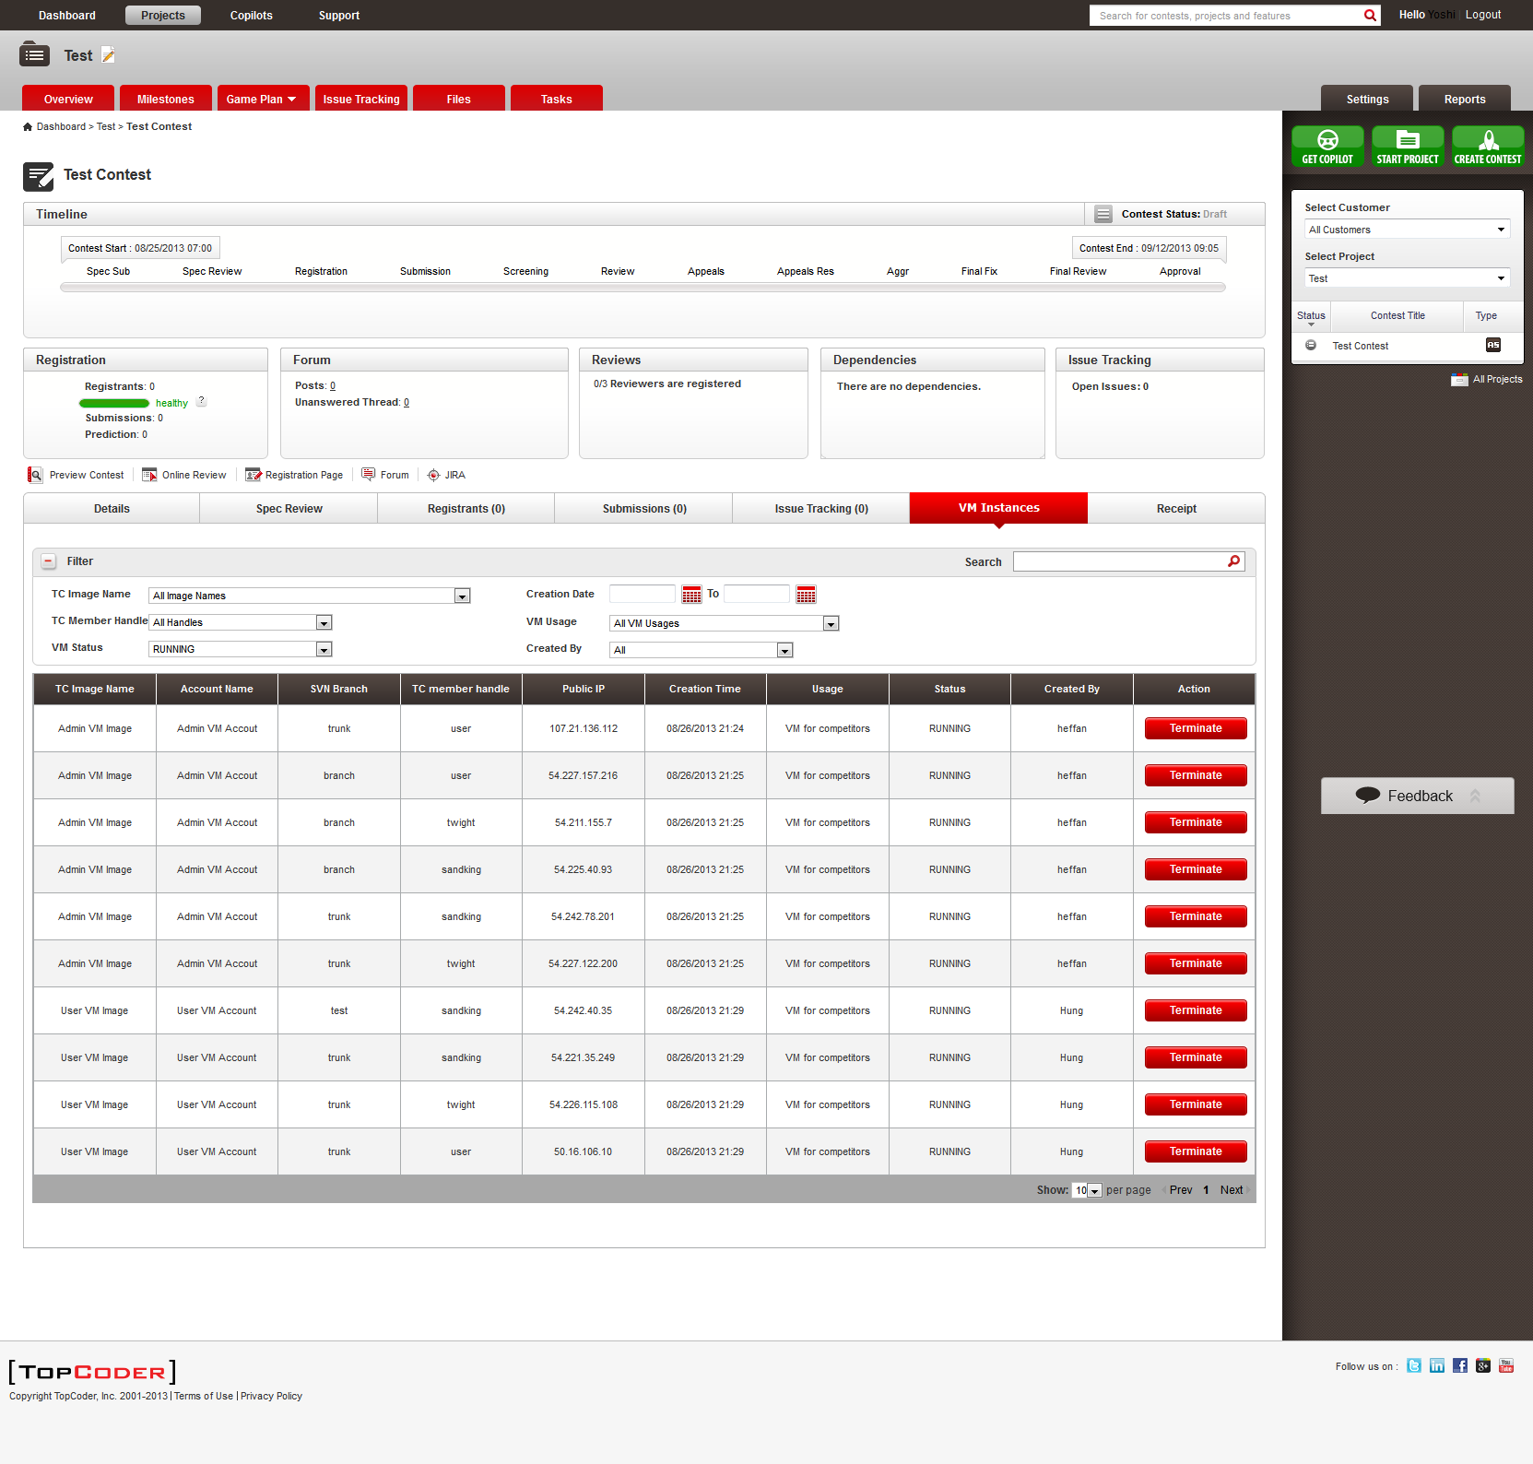

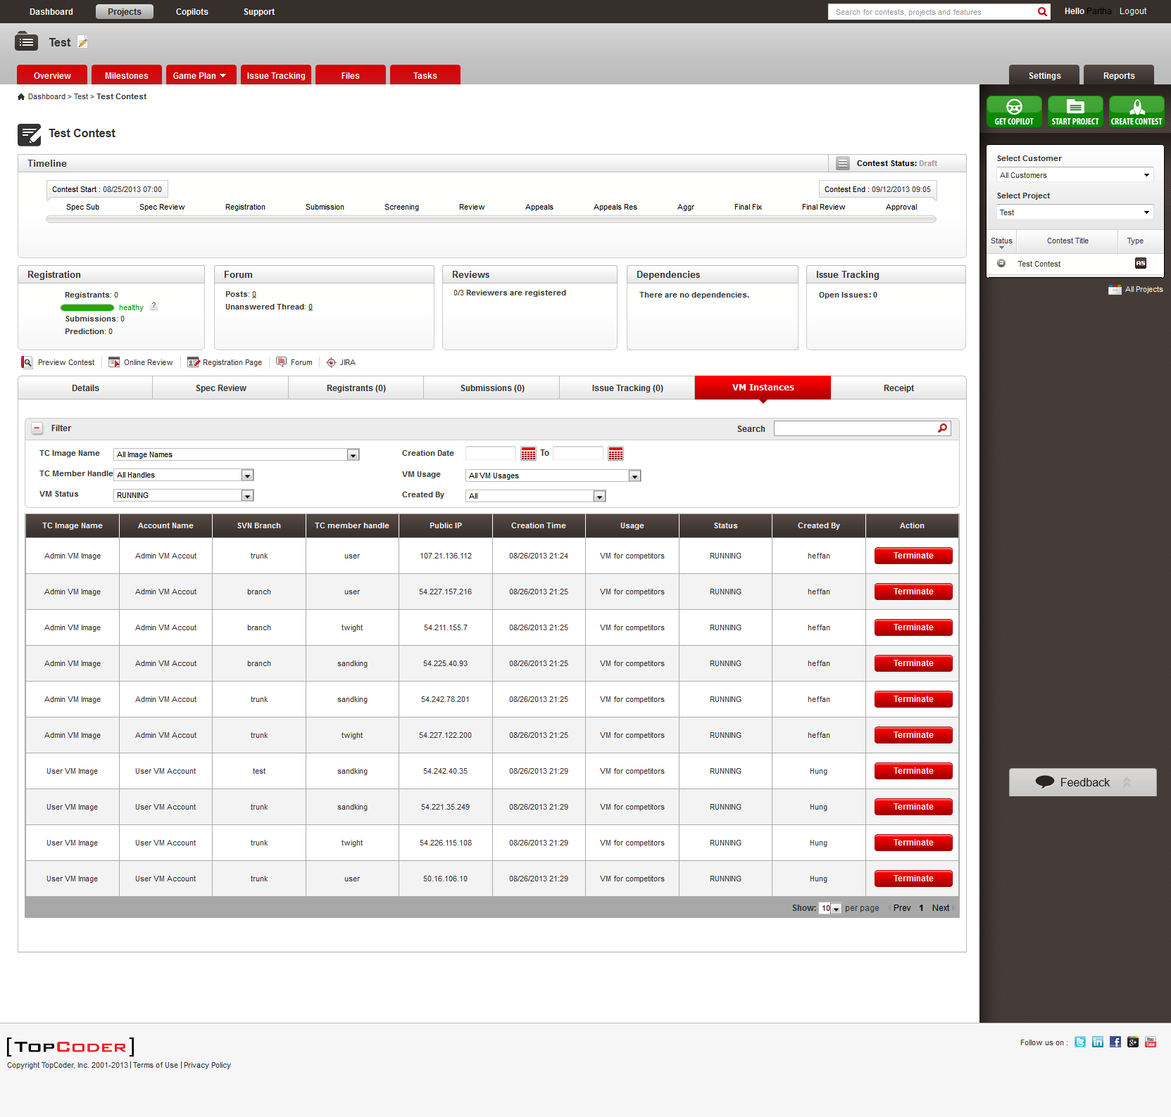

  - You can play with the Terminate button from different roles, all are working properly.

